Architecture:
- By default, the matrix multiplication support both output-stationary and weight-stationary dataflows, which programmers can pick between at runtime. However, the dataflow can also be hardened at elaboration time.
- Because weight-stationary dataflows require an accumulator outside the systolic array, they add a final SRAM bank, equipped with adder units, which can be considered an extension of the scratchpad memory space. The systolic array can store results to any address in the accumulator, and can also read new inputs from any address in the accumulator.
- The DMA engine can also tranfer data directly between the accumulator and main memory, which is often necessary to load in biases.
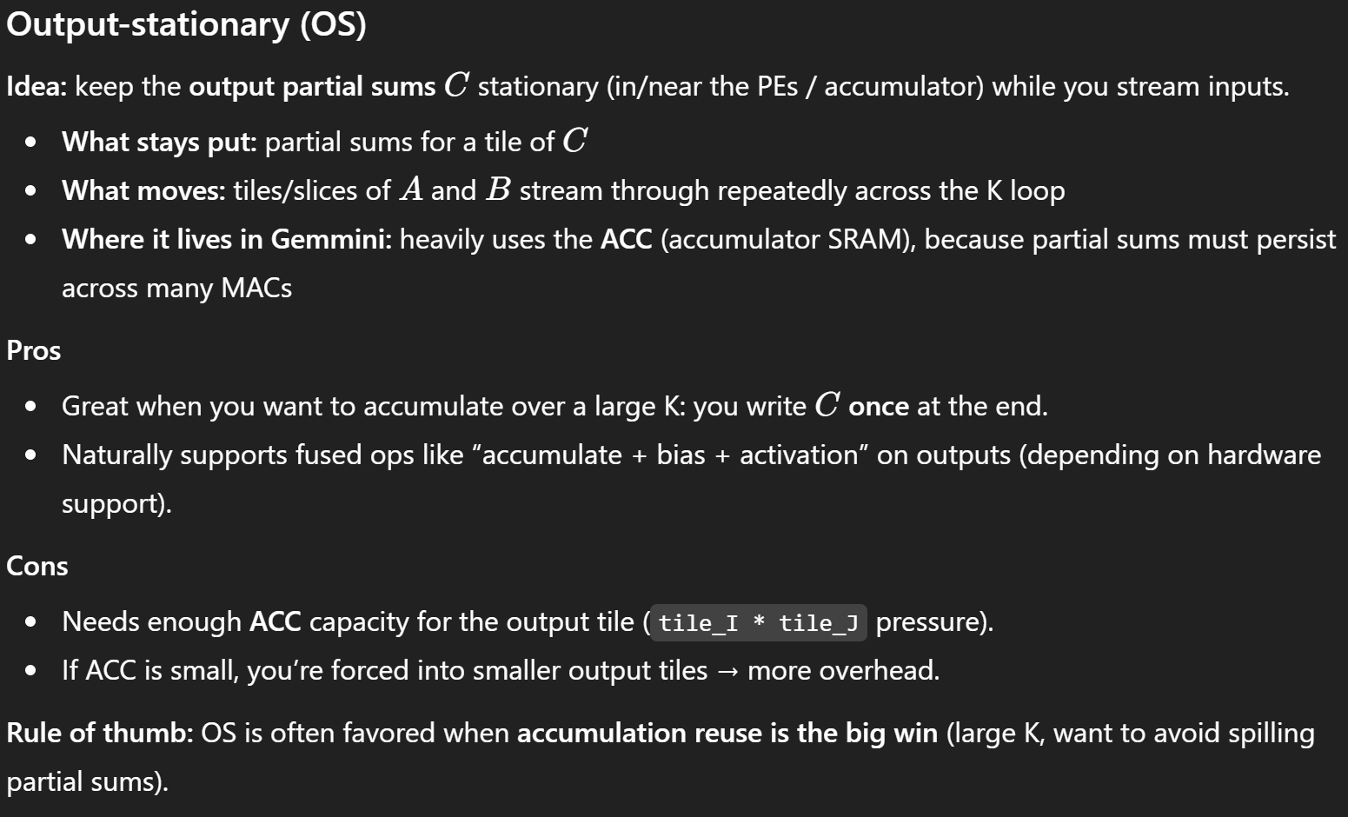
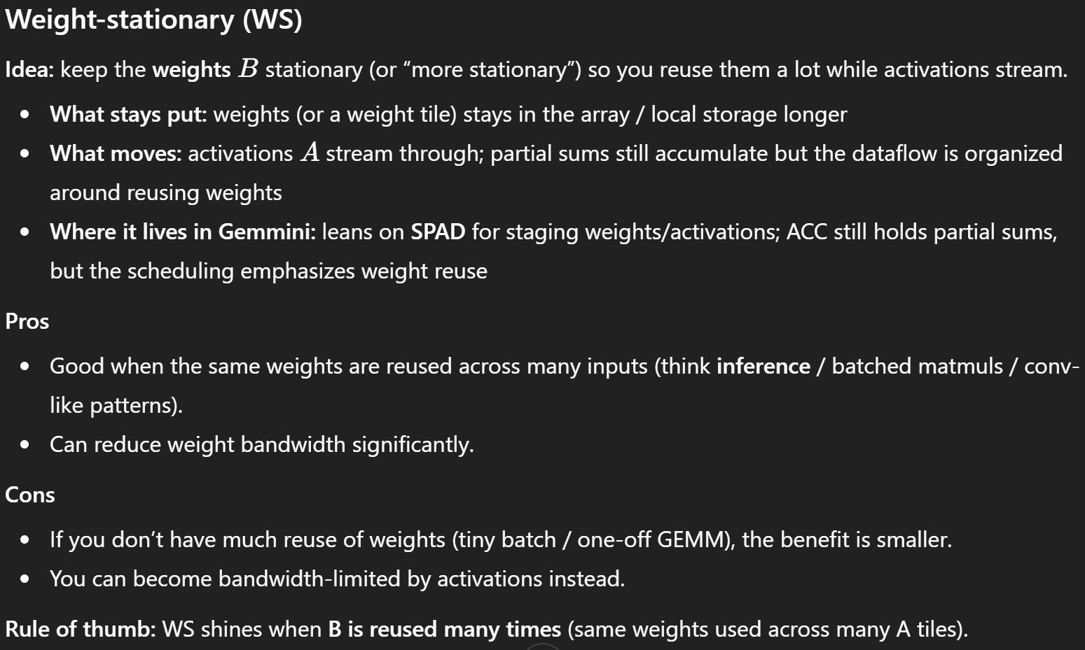
Error for Java heap max limit reached:
Exception in thread "main" java.lang.OutOfMemoryError: Java heap space
at scala.util.control.NonFatal$.apply(NonFatal.scala:42)
at scala.util.control.NonFatal$.unapply(NonFatal.scala:48)
at chisel3.internal.Builder$.$anonfun$buildImpl$1(Builder.scala:1050)
at chisel3.internal.Builder$$$Lambda$831/0x000009ffa83a4d48.apply(Unknown Source)
at scala.util.DynamicVariable.withValue(DynamicVariable.scala:59)
at chisel3.internal.Builder$.buildImpl(Builder.scala:1034)
at chisel3.internal.Builder$.$anonfun$build$1(Builder.scala:1025)
at chisel3.internal.Builder$$$Lambda$829/0x000009ffa83a47c8.apply(Unknown Source)
at logger.Logger$.$anonfun$makeScope$4(Logger.scala:148)
at logger.Logger$$$Lambda$119/0x000009ffa812ed00.apply(Unknown Source)
at scala.util.DynamicVariable.withValue(DynamicVariable.scala:59)
at logger.Logger$.makeScope(Logger.scala:146)
at logger.Logger$.makeScope(Logger.scala:133)
at chisel3.internal.Builder$.build(Builder.scala:1025)
at chisel3.stage.phases.Elaborate.$anonfun$transform$1(Elaborate.scala:53)
at chisel3.stage.phases.Elaborate$$Lambda$818/0x000009ffa839e970.apply (Unknown Source) at scala.collection.immutable.List.flatMap(List.scala:294)
at scala.collection.immutable.List.flatMap(List.scala:79)
at chisel3.stage.phases.Elaborate.transform(Elaborate.scala:36)
at chisel3.stage.phases.Elaborate.transform(Elaborate.scala:26)
at firrtl.options.DependencyManager.$anonfun$transform$5 (DependencyManager.scala:280)
at firrtl.options.DependencyManager$$Lambda$375/0x000009ffa82f9548.apply (Unknown Source)
at firrtl.Utils$.time(Utils.scala:53)
at firrtl.options.DependencyManager.$anonfun$transform$3 (DependencyManager.scala:280)
at firrtl.options.DependencyManager$$Lambda$373/0x000009ffa82f5fa8.apply (Unknown Source) at scala.collection.LinearSeqOps.foldLeft(LinearSeq.scala:183)
at scala.collection.LinearSeqOps.foldLeft$(LinearSeq.scala:179)
at scala.collection.immutable.List.foldLeft(List.scala:79)
at firrtl.options.DependencyManager.transform(DependencyManager.scala:269)
at firrtl.options.DependencyManager.transform$(DependencyManager.scala:255)
at firrtl.options.PhaseManager.transform(DependencyManager.scala:443)
at chipyard.stage.ChipyardChiselStage.run(ChipyardStage.scala:33)
make: *** [/home/su5ti/SsysArch/gemmini/chipyard/common.mk:151: /home/su5ti/SsysArch/gemmini/chipyard/sims/verilator/generated-src/chipyard.harness.TestHarness.NoDebugCustomGemminiSoCConfig/chipyard.harness.TestHarness.NoDebugCustomGemminiSoCConfig.fir] Error 1

Analysis (throughput vs Queue Width):
- Software Tiling: software tiling changes how the matrix multiplication is split into smaller blocks that fit in Gemmini's on-chip memories and run efficiently.
- REPS (repeats) helps measure throughput reliably. It repeats the same matrix multiplication many times so the timing is dominated by steady compute/memory behavior instead of one-time overheads:
- Things like command setup, DMA launch overhead, fences, pipeline fill/drain, and any one-time effects.
- Reduces noise.
- SPAD = scratchpad:
- A fast on-chip memory inside the accelerator.
- Used to hold the input tiles of matrices (A and B), and sometimes other temporary data depending on the kernel.
- ACC = accumulator:
- A fast on-chip memory used to hold partial sums or final outputs of matrix operations.
- It stores values in a wider datatype than inputs.

SPAD = 256KiB, ACC = 64KiB:
NMD = 32, REP = 3 (Not fix software tiling) NMD = 128, REP = 25 (Fixed software tiling -16x16 PEs, 1 tile):
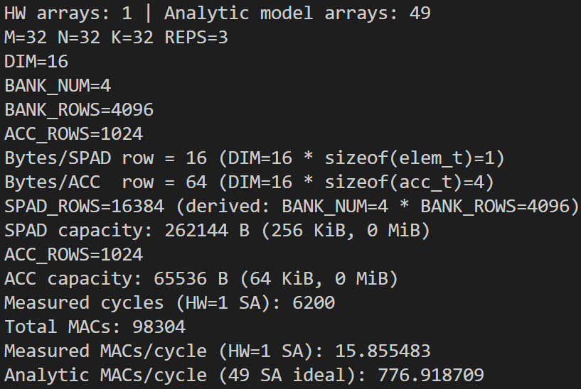
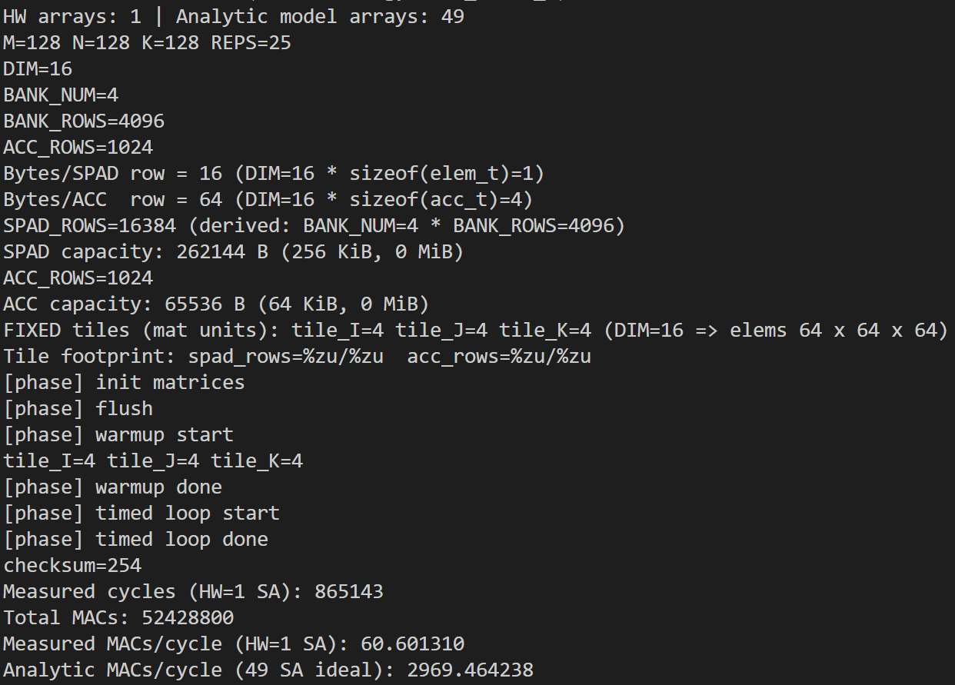

SPAD = 256KiB, ACC = 128KiB:
NMD = 128, REPS = 25 (Fixed Software Tiling - 16x16 PEs, 1 tile)
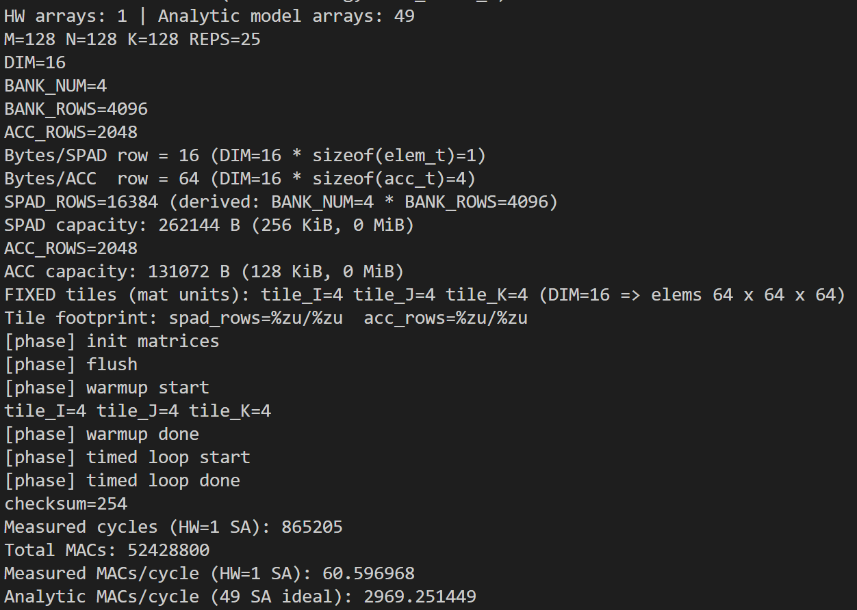
8x8 PEs VERSION (Fixed software tiling - 8x8 PEs, 8x8 tiles):
- SPAD = 512 KiB, ACC = 128 KiB:
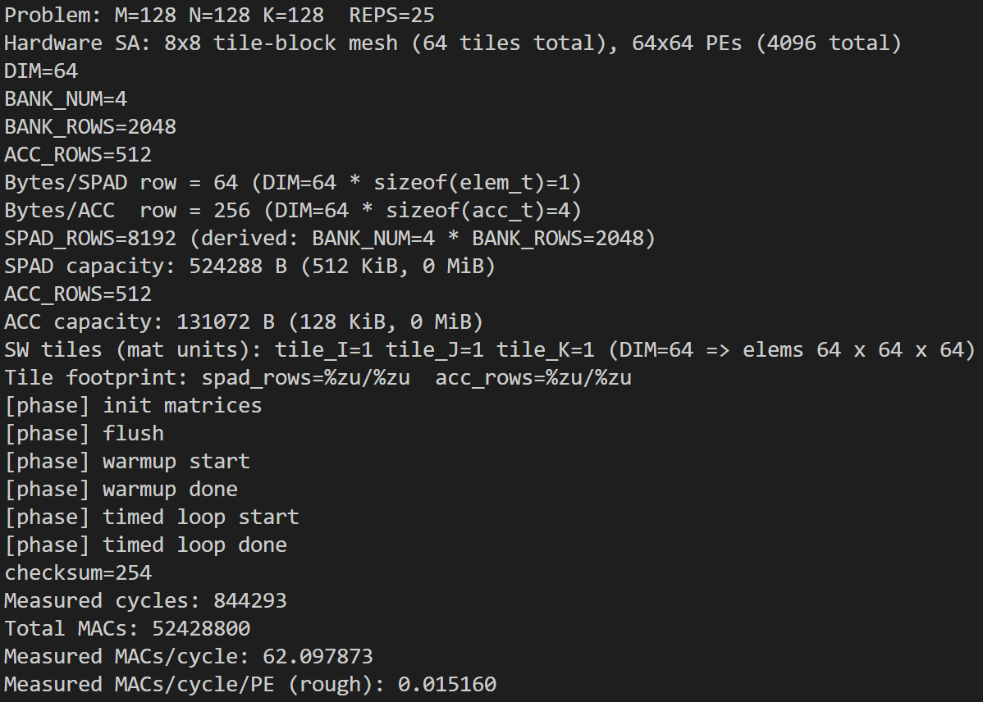
- SPAD = 512 KiB, ACC = 256 KiB: Same Performance
- SPAD = 1024 KiB, ACC = 128 KiB:
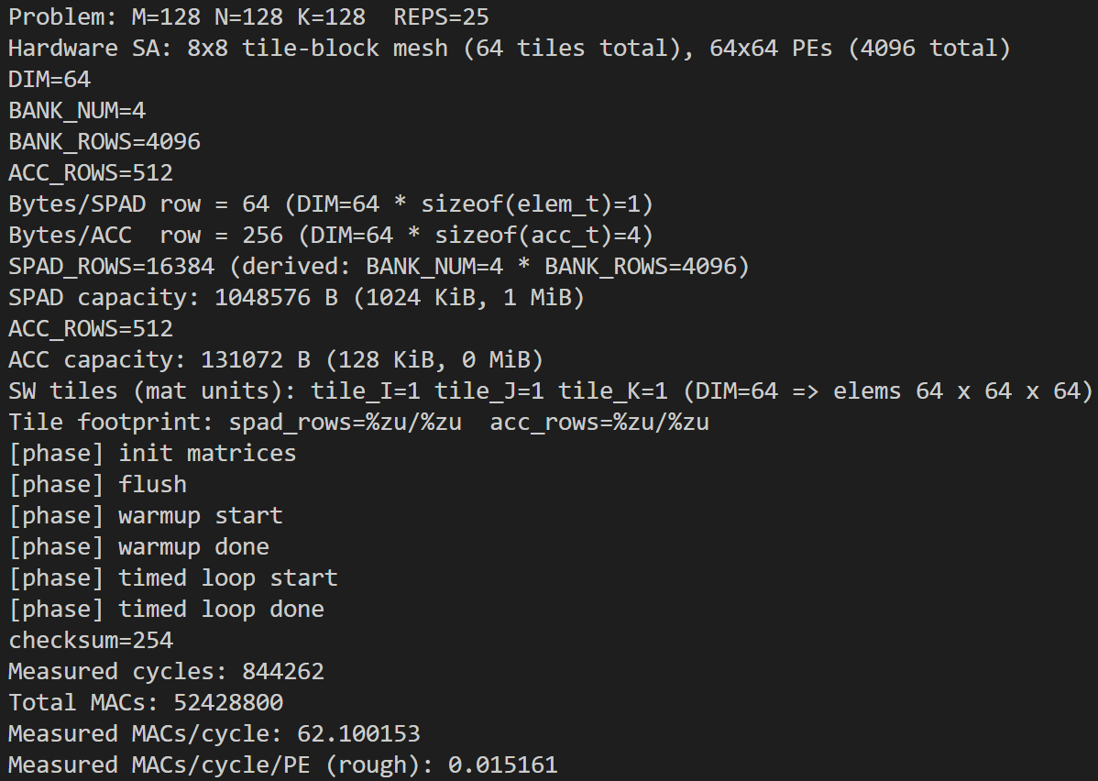
- SPAD = 512 KiB, ACC = 64 KiB (REPS go from 25 to 5)
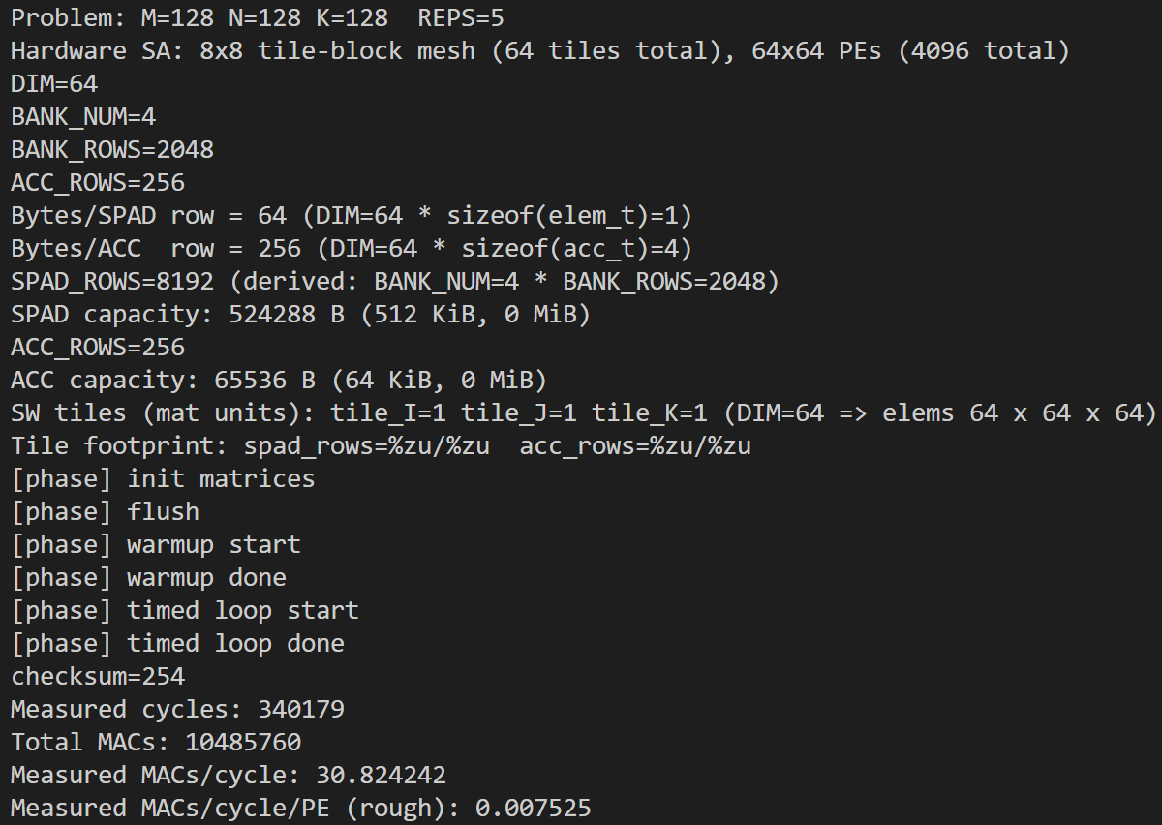
- SPAD = 128, ACC = 32: Error occurred saying not enough SRAM
- SPAD = 128, ACC = 64 (Problem increases to 256, 256, 256):
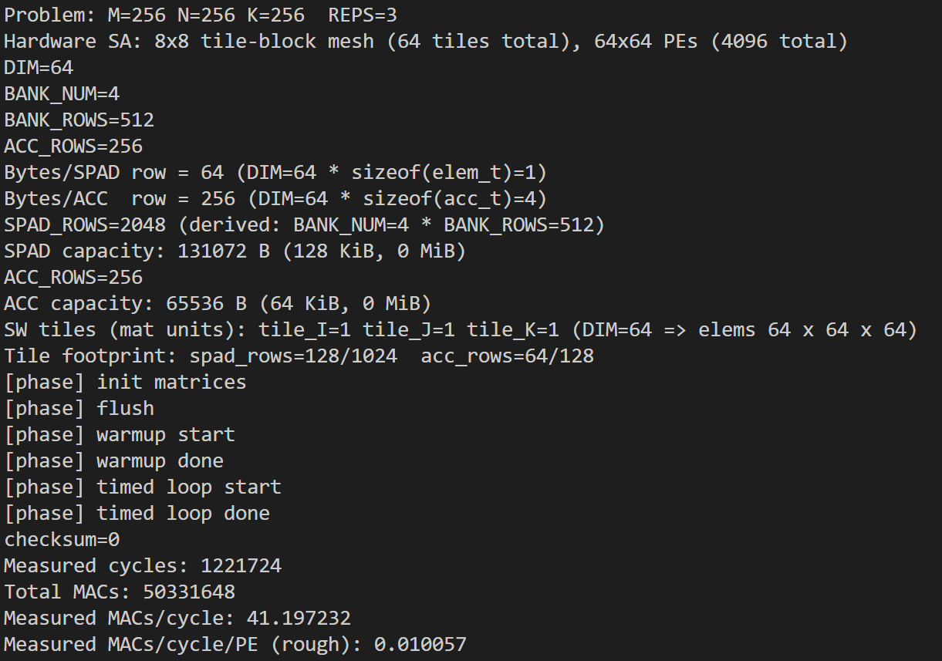
- SPAD = 256KiB, ACC = 64KiB
